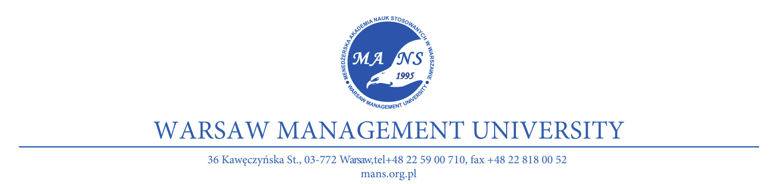
Warsaw, ___________
Mr Ambassador
of the Republic of Poland
in ___________________
_____________________

in relation to applying for a Polish student visa by __________, the citizen of _____________, born _____________, passport number _____________, we would like to inform you that the candidate, apart from submitting the originals of documents, met all the admission requirements to be admitted to 1st degree (undergraduate) studies, in Bachelor of Management (Business Management), run in Russian at the Warsaw Management University (WMU). Studies are planned to begin on _____________ and will last until _____________. In the recruitment process, the applicant provided copies of all the required documents and paid the fee for the first year of studies in the amount of ______ EUR.
All classes for first semester students as well as selected classes and seminars for students of higher semesters will be carried out in a traditional form at the University's campus. Lectures and seminars will be conducted with the use of distance learning methods and techniques.
For the purpose of completing the recruitment process and entering the applicant onto the list of students, immediately after arriving in Poland following original documents must be delivered to WMU: diploma (certificate, other document) recognized in the Republic of Poland as being eligible to apply for admission to studies, in accordance with the relevant regulations with an apostille, Bachelor’s Diploma with apostille for master's studies, passport, marksheet, photo.
We would also like to inform You that the student may start the studies with a maximum delay of 30 days from the beginning of the semester. In the event of a longer delay, the Rector's consent is required.
We would also like to inform you that in accordance with our standards for foreign language students, every student will be under our representative`s care throughout the period of study at our University. The student is obliged to inform the WMU Admission office about his/her arrival to Poland 7 working days before.
The rector's proxy for education in Russian laguage, Valeriy Kuznetsov, PhD hab., professor WMU, is responsible for the whole process of international student recruitment for Russian studies and can be contacted by phone at +48 887 542 507 (including WhatsApp) or by email valeriy.kuznetsov@mas.org,pl
WMU is entered into the register of non-public universities, maintained by the Ministry of Science and Higher Education under the number 60.
signature of the rector

